

# NHS Pensions

**NHS Pensions Online (POL) guide**

# 15. SS10 Joiner Form

#### This joiner form should be used for all eligible staff at trusts, clinical commissioning groups (CCG), general practitioner (GP) practice Doctors and direction employers.

It should not be used for practitioners, assistant practitioners, locum practitioners or non-medical GP practice employees.

Once you have accessed the E-Forms menu select the link for the SS10 and you will be presented with a page asking for the members’ personal details, as follows:

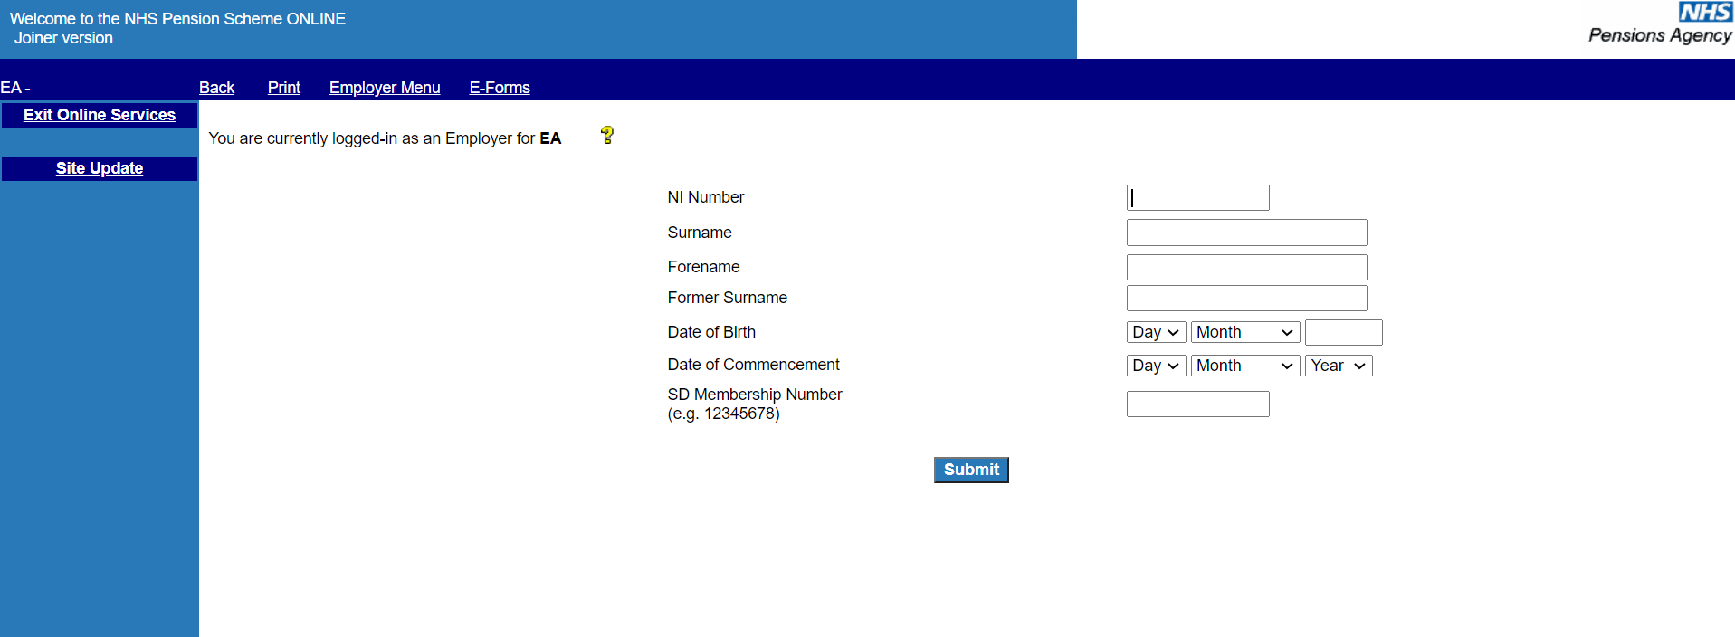

It is essential that correct information be entered on this screen to enable the joiner form to be processed to the correct member record.

**Important Note:**

If you do not know, or are unsure of, the members’ NI number then this field should be left blank. If the member has been issued with a temporary NI number by HM Revenue and Customs (HMRC) (NI number prefixed with TN) or a temporary NI number used by the NHSBSA (NI number prefixed with ZZ) you should not use these numbers and the field should be left blank.

The following fields must be completed for you to be able to proceed and submit full joiner details:

Surname

Forename(s)

Former surname (maiden name), if applicable

Date of Birth

Date of Commencement (start date of this employment not date member originally joined the Scheme)

Existing scheme members will already have a Superannuation Division (SD) reference number but if you do not know this information the field should be left blank.

If you know the members NI number you can do a search for the SD number via the **“Member Search”** link on the main Employer menu.

If the search identifies an existing member record for the NI number entered it is important to check that the traced record matches your employee by checking their full name and date of birth against that of the traced record.

Where the details do not match, then the NI number you hold must be checked with HMRC. In these cases, you can submit the joiner form without an NI number.

When this page has been completed and you select “submit” you will be taken to the SS10 joiner form.

Where an existing member record is found the SD number will be pre-populated on the joiner form, as follows:

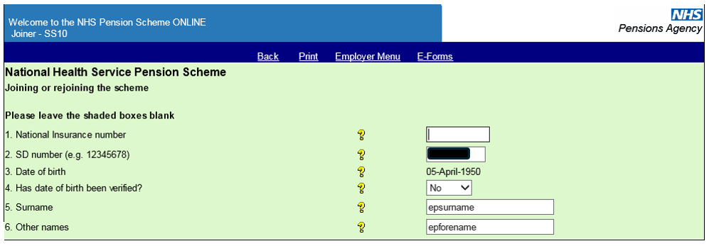

When you click “submit” a range of validation checks are performed on the information input and error messages will be produced where invalid or mismatching information has been entered.

The following pages show examples of some of these checks and error messages.

If the Date of Commencement overlaps with the dates of a previous employment you will receive a message as follows:

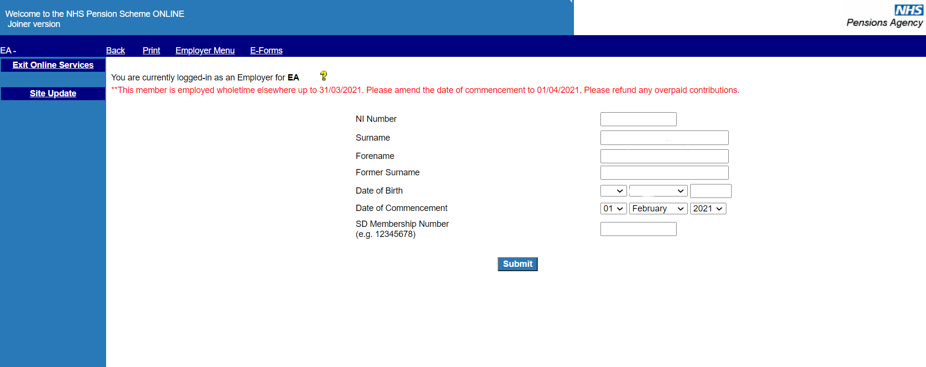

If you submit a joiner that matches identically to an existing employment with your authority/GP practice, you will receive the following message:

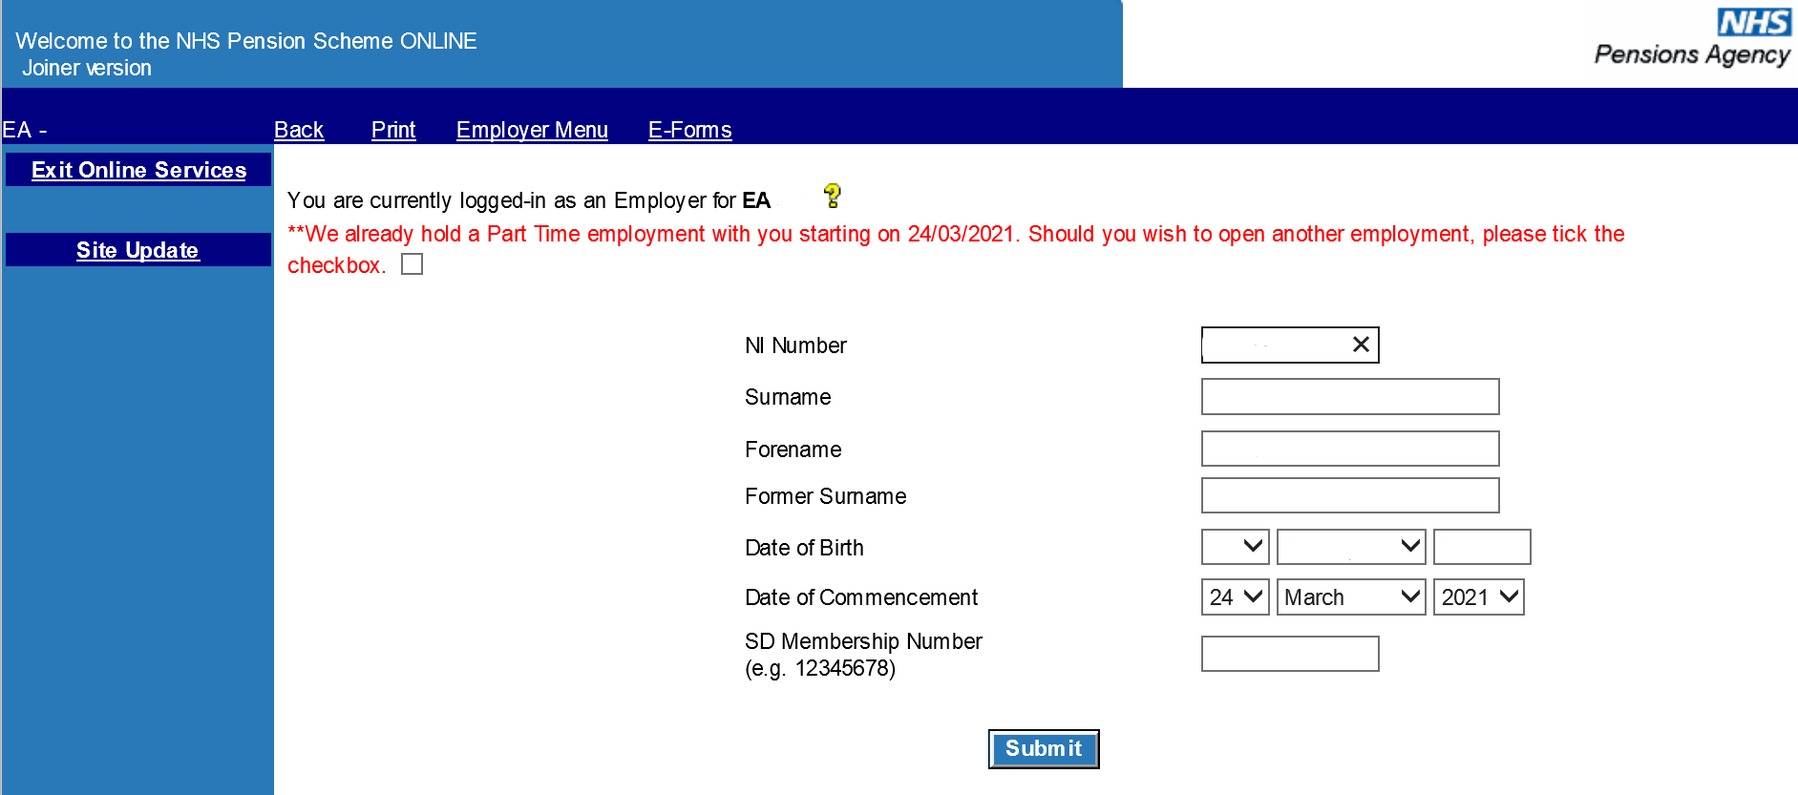

Before continuing you should ensure that the joiner details you are submitting are not a duplicate and that this is a genuine concurrent part time employment.

If you do not wish to continue with the submission select either “Employer Menu” or “E-Forms” on the dark blue bar at the top of the screen.

If you are submitting a joiner for an existing member and enter a Date of Birth that does not match the details held by the NHSBSA then you will still be taken to the joiner form but the DOB displayed will be that held by the NHSBSA, and a message will be displayed on the page advising of this fact, as follows:

A screenshot of a computer

You should then verify the members correct Date of Birth by sight of their birth certificate and submit a form **SD55G** if the date held by the NHSBSA is incorrect.

The joiner form holds various other validations and if mismatching details are entered you will receive an on screen error message.

For example:

* If you state the member is male then the title you select should not be Mrs, Miss or Ms
* If you state the employment is whole time then you should not enter any details for the contracted and standard part time hours/sessions
* If you select a capacity code of “01” (nurse, physiotherapist, midwife or health visitor) then the employment type must be “officer” and the “As & When” and “Locum” fields must = “no”.
* If you select a capacity code of “03” (doctor) then the employment type must be “specialist or non-specialist”
* An employment can only be shown as “Maximum P/T Specialist” if the capacity code is “03”, the employment type is “Specialist” and the actual and standard sessions are completed as 10/11ths.

Examples of some error messages are as follows:

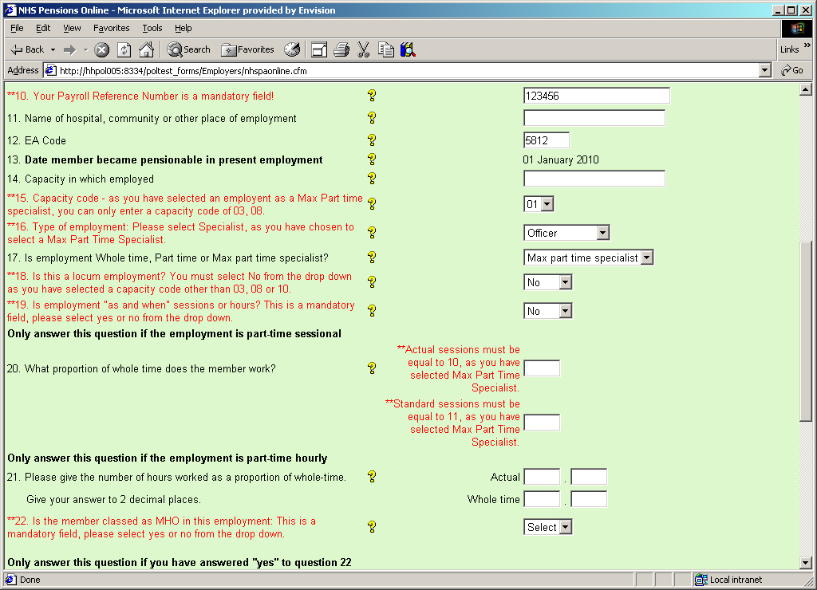

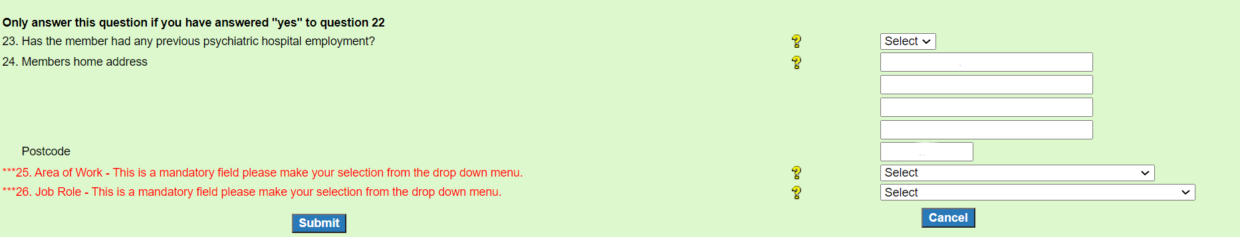Fields 25 - 26 on the joiner form are in relation to the job role and the area of work.

On these fields the options for completion are held in the drop down menu by selecting the arrow at the side of the completion area:

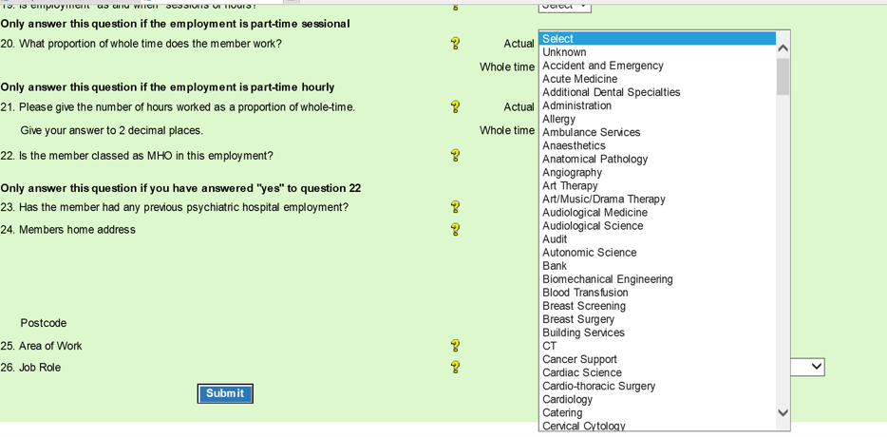

Once the joiner form has processed you will receive an **SD55 Notification** via Pensions Online, generally the next day.

If no **SD55 Notification** is received and the member does not appear on your list of employees on the **ADP4** form then this is an indication that the joiner form has not processed successfully and you should check your **Error Handling.**

If there no error has been produced in Error Handling then the error may be for the NHSBSA to resolve and you should contact us for further information.